**Functional Document**

|  |  |
| --- | --- |
| **Application** | NGERP - Centra |
| **Service Bundle** | Integrations |
| **Service Request** | Import Payment Netoff |

**Description :**

User can import payment netoff using import file loader. Payment netoff is used to make payment to the AR invoice in Region. some customers directly make payment to abbott, so abbott make a centrilized payment netoff which will be synched to region.

**Workflow Process :**

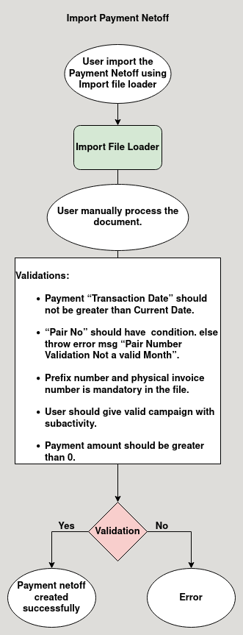

**Business Rules :**

* User can only import payment netoff in HQ.
* User use import File Loader Screeen to import the payment netoff.
* After import the payment netoff it will show in import payment netoff temporary screen.
* User should manually process the document in the temporary screen.
* Validations:
  + Payment “Transaction Date” should not be greater than Current Date, else throw error message.
  + “Pair No” should have below condition. else throw error msg “Pair Number Validation Not a valid Month”.
    - Pair Number Validation First Character should be 3.
    - Next two letters is current Day.
    - 4th and 5th letters refer to month.
    - 6th letter should be “-”.
    - last 3 letters user choice.
  + Prefix number and physical invoice number is mandatory in the file.
  + User shoul give valid campaign with subactivity.
  + Payment amount should be greater than 0.